

Digital Transformation Directorate

November, 2025

Epassport System Report 179 +81

Contents

Objective 2

1. Merging: 2

2. Slowness – time consuming: 3

5. Not found 3

6. Biometric lost after submission 4

7. Watch list not display detail info: 4

9. Incorrect Place of Birth for Watch List Entries 5

10. Topan officers Not Responding promptly…………………………………...…………………………………………………5

11. Personal Data Lost After Case Resolution 5

12. Visa and Origin ID Not Extended 5

13. Displayed Visa Amount Mismatch 5

14. Visa Not Found During Correction Process 5

15. Final Receipt Changes after Correct Refill 6

16. Data Entry Blocked After Fix: 6

17. Date Format Conversion Challenge 6

18. Duplication of App No 6

19. Iris Biometric:- 7

20. System Automatically Changes Urgent Service to Normal Service 8

21. Application Status Changes from “Not Found” to “On Payment” 8

22. Incorrect Penalty Fee for Neighboring Countries 8

23. Overcharged Replacement Fee for Lost Yellow Card Abroad 9

24. Inability to Extend Visa and Yellow Card Processed in Toppan System 9

25. Exit Visa Not Processing in the System 9

26. Incorrect Penalty Calculation for Expired Yellow Card after Entry 9

27. Yellow Card Not Processed for Underage Users 9

28. Editable Application Number and Nationality in the Whitelist 9

29. Payment Receipt Displays Amount in Dollars Instead of Ethiopian Birr (casher) 9

30. Skipping Pages and Inconsistent Printing Format 10

# Objective

To identify and address ongoing development needs of the system by reporting system issues and ensuring that the system operates efficiently and effectively.

# Merging:

Taking data from one record (like biometric, name, and photo) and combining it with another record to make them one.

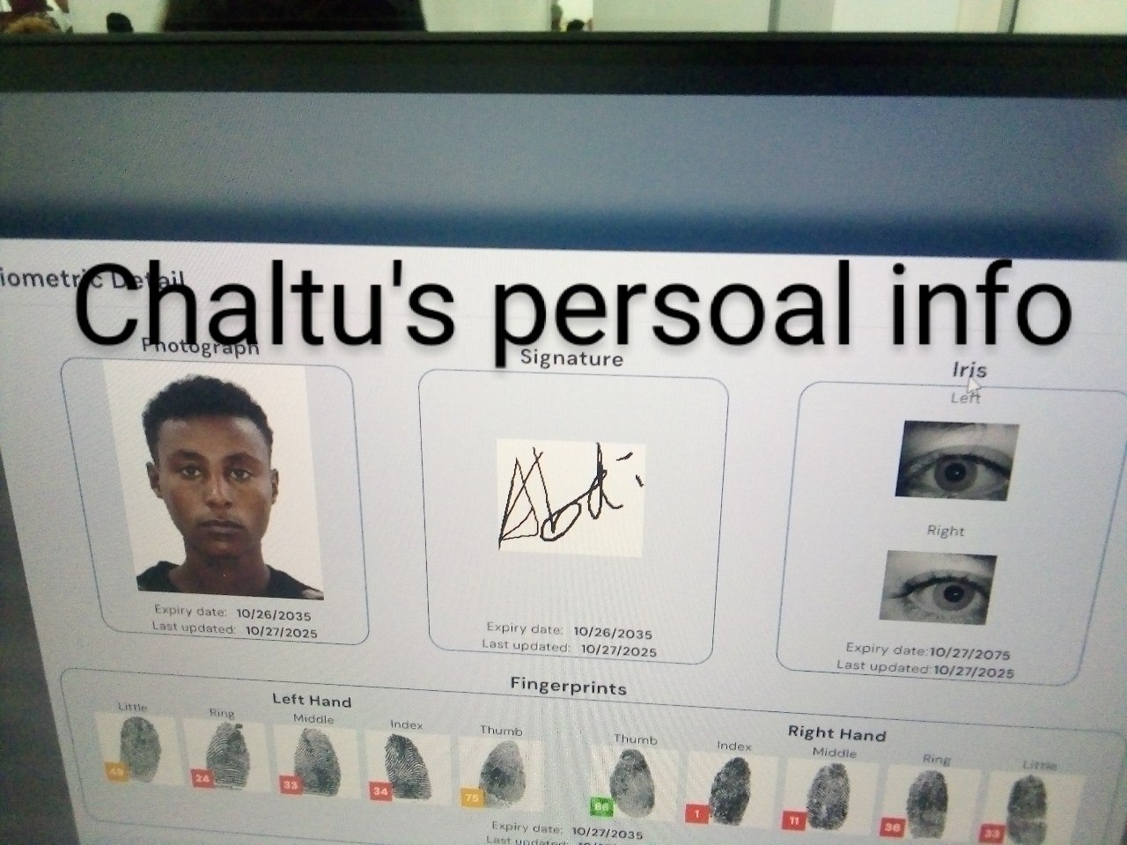

# Slowness – time consuming:

The system is very slow to respond, making every step take much longer than expected. And system performance is slow.



1. **To open or to process a task, the system says "In Progress"**:

When trying to open or process a task, the application system shows “**In Progressing**" and does not allow further action.

1. **Calendar conversation issue**:

The system does **not correctly convert dates between the Ethiopian calendar and the Gregorian calendar.**

# Not found

Several data, records, or files cannot be found in the system when searched.

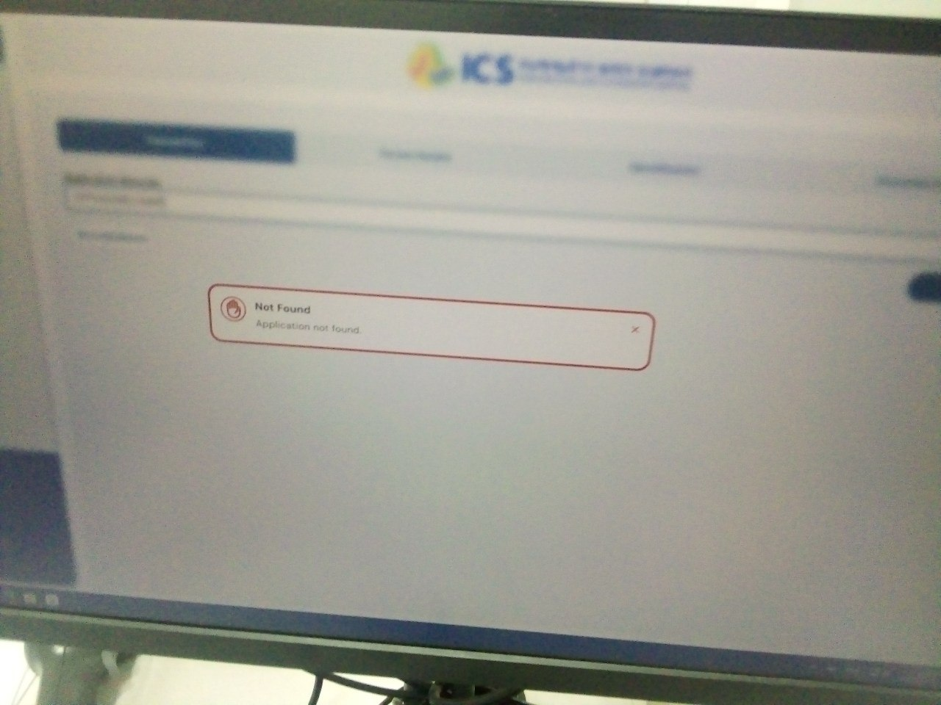

# Biometric lost after submission

* In the validator role, captured biometric data (fingerprints and photo) is lost, requiring the officer to capture it again.

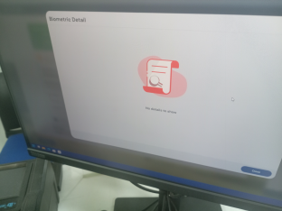

# Watch list not display detail info:

* Only display first name and last name, detail info fetch from Ina.
* The system assigns the same application number to two different people and some individuals listed in the Watch List have their Place of Birth shown as locations outside the country, which is inconsistent or inaccurate.

**8. Photo Not Displaying in Watch List**  
Photos of individuals in the **Watch List** are not displaying in the system. Without photos, it becomes hard to visually verify or identify persons under watch, reducing system reliability and security.

# ****9. Incorrect Place of Birth for Watch List Entries****

**10. Topan officers Not Responding Promptly**

The **Topan** officers not respond quickly when there is a case. This delay disrupts workflow, slows decision-making, and affects customer service efficiency.

# ****11. Personal Data Lost After Case Resolution****

After resolving a case, all personal data of the individual is deleted from the system. As a result, when the same person needs further processing, their information must be entered again from the start. This causes unnecessary duplication of work and risk of data inconsistency.

# ****12. Visa and Origin ID Not Extended****

The **Visa** and **Origin ID** extensions are not properly updated in the **system**. When such updates are attempted, the system fails to record them and forces users to revert to the **old (INA)** system for completion. This shows lack of synchronization between the old and new platforms.

# ****13. Displayed Visa Amount Mismatch****

The system displays **Origin ID** fee or count of **650**, but the correct value is **550** when the **Origin ID** is lost which is valid. This inconsistency can cause financial errors and confusion during payment or replacement processing.

# ****14. Visa Not Found During Correction Process****

When a visa case is brought back for correction, the system cannot find the previous visa record. This may occur due to improper case linking, missing database references, or incomplete data migration. It prevents smooth correction and delays service delivery.

# ****15. Final Receipt Changes after Correct Refill****

Even after the form is correctly filled and re-submitted following instructions, the **final receipt** shows changes or inconsistencies. This can misrepresent the applicant’s details or payment information, indicating a problem with the update or data-saving mechanism.

# 16. Data Entry Blocked After Fix:

After fixing the "not found" error, the system no longer allows users to fill in or enter data.

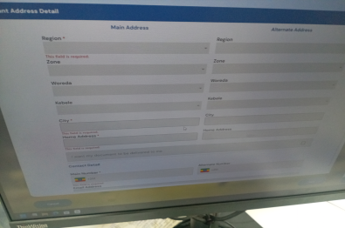

# 17. Date Format Conversion Challenge

When a date is entered in DD/MM/YY (Day/Month/Year) format, the system often automatically converts the display to MM/DD/YY (Month/Day/Year).This automatic conversion causes confusion because it becomes difficult to differentiate the day from the month when the numerical value for the day is less than 12.

# 18. Duplication of App No

It generates two barcodes for one person.

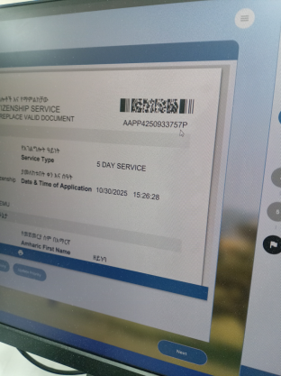

# 19. Iris Biometric:-

After taking the iris of two person, if we try to take the iris of a third person, it cannot be done unless we restart the computer.

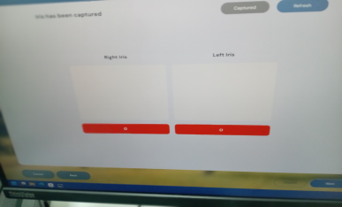

# ****20. System Automatically Changes Urgent Service to Normal Service****

When a user selects the **urgent service option**, the system later **changes it automatically to normal service** without authorization. This causes delays in processing time, confusion for applicants, and inconsistency in service prioritization.

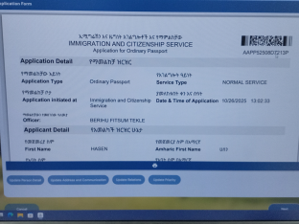

# ****21. Application Status Changes from “Not Found” to “On Payment”****

An application initially shows the status **“Not Found”**, but on the following day, it changes to **“On Payment.”** This inconsistency indicates a **delay or synchronization problem** between the application database and the payment system. It can cause confusion for applicants and staff, making it unclear whether the application truly exists or if the payment process has been correctly initiated.

# ****22. Incorrect Penalty Fee for Neighboring Countries****

The penalty for neighboring countries should be 10 dollars, but it is set to 20 dollars.

# ****23. Overcharged Replacement Fee for Lost Yellow Card Abroad****

When the yellow card is valid and the person loses it abroad, they are supposed to pay 550 dollars, but they are made to pay 650 dollars.

# ****24. Inability to Extend Visa and Yellow Card Processed in Toppan System****

If both the visa and yellow card previous were processed in the Toppan system, it cannot be extended.

# ****25. Exit Visa Not Processing in the System****

The system is not processing the exit visa.

# ****26. Incorrect Penalty Calculation for Expired Yellow Card after Entry****

If the yellow card expires after entering the country, currently there is no penalty for the first 10 days. After 10 days, a $5 penalty should be applied, but the system is not functioning this way.

# ****27. Yellow Card Not Processed for Underage Users****

The system is not processing the yellow card for underage users.

# ****28. Editable Application Number and Nationality in the Whitelist****

Within the system, the application number of applicant and other person who are in the whitelist and the applicant's nationality can be changed."

# ****29. Payment Receipt Displays Amount in Dollars Instead of Ethiopian Birr (casher)****

When a person makes a payment in **Ethiopian Birr**, the system incorrectly displays the total amount in **U.S. dollars** on the receipt. This creates confusion for both customers and finance staff and may cause issues in financial reporting and currency reconciliation.

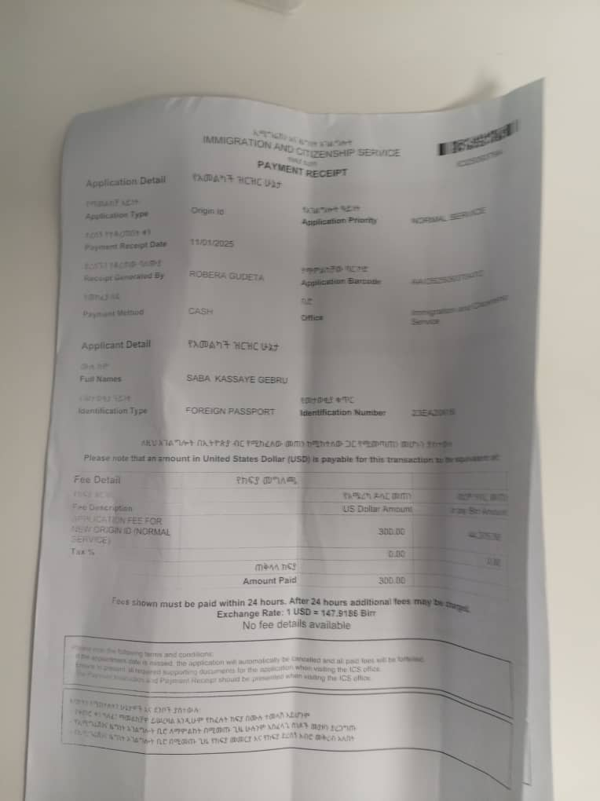

# 30. ****Skipping Pages and Inconsistent Printing Format****

Since **October 31, 2025**, the printer has not been functioning properly. It **skips pages during printing**, causing incomplete document outputs. Additionally, it **prints visas on both sides** of the paper but **prints IDs on only one side**, leading to inconsistency in document formatting and potential rejection of official documents. The issue may be due to incorrect printer settings, hardware malfunction, or a system-to-printer configuration error.

